

CMPSC 463 (Spring 2026)
Dsgn Analysis Algs

Project 2

Aram Asdourian
Matthew Wybranski

Instructor: Janghoon Yang

Submitted On: 4/26/2026

Table Of Contents
# | Section | Page
1 | Project Description | 3
2 | Project Significance | 3
3 | Code structure | 4
4 | Algorithms Description | 5
5 | Algorithms Verification | 7
6 | Execution Results and Analysis | 8
7 | Conclusions | 12
8 | AI Usage | 12

Project Description
The objective of this project is to implement Dijkstra’s algorithm to simulate real world path finding when delivering humanitarian aid. The graphs used in this project represent road structures in an area of the world that needs humanitarian aid, the weights represent the time and risk associated with taking that path. The implemented algorithm determines the best path that aid deliveries should take to reach their destination.

Project Significance
This project represents the real-world significance of bringing aid to those who need it in times of war/armed conflict. Dijkstra’s algorithm is important to use here as it helps map out the fastest route from an aid center/hub to the location of those who need it.

Code Structure
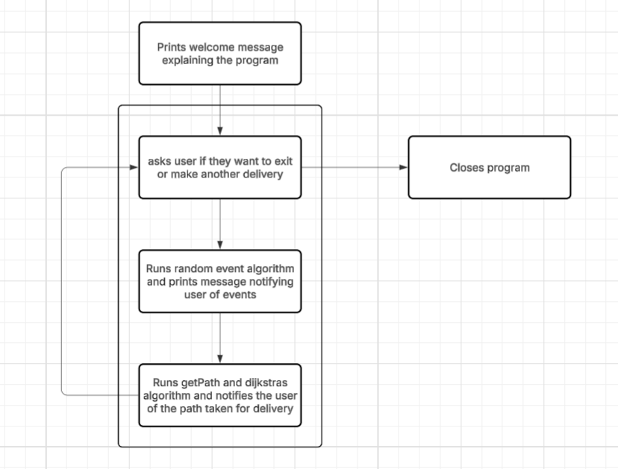

The program starts with a welcome message telling the user about the program, how to use it, and how it works. Then the program enters the main user interface loop

At the start of every loop, the user is presented with information on the graph and asked if they want to make a delivery or exit the program. If the user chooses to exit, the program closes. If they choose to continue, then the program proceeds to run our 3 main algorithms to make a delivery

First the random event algorithm is run, This randomly changes the weights in our graph to create a unexpected and different graph for each delivery. The user will be given a message explaining a real-world reason why the weight has shifted (example: “military presence has increased on this road, +3 weight”).

Then the getPath algorithm is run on the modified graph with a start point (aid center) and end point (delivery location). This algorithm first runs our modified Dijkstra’s algorithm which functions like a normal Dijkstra's algorithm but instead of returning the cost, it also returns a dictionary containing every path taken from one node to another. The getPath algorithm takes the information returned by the modified Dijkstra's and builds a list of the path taken by Dijkstra’s to reach the specified endpoint.

The information taken by the getPath algorithm is then displayed for the user, The graph is then reset to its original state and the loop returns to asking the user if they want to continue or exit.

Algorithm Description

Modified Dijkstra’s
One of the algorithms used in this project Is a modified Dijkstra’s algorithm. The standard Dijkstra’s algorithm takes a graph and a starting point and finds the optimal path to every node within a weighted graph. The modification made to this algorithm is that in addition returning the cost to reach each node it also returns a list of each optimal path taken from one node to another

Get Path
The get path algorithm interprets the list of paths returned from the modified Dijkstra’s algorithm. It accepts a start and end point and reverse engineers a list of the best path by indexing for each node starting from the end and travelling up to the start. After the path is found it reverses the list and returns a tuple containing the path and the weight of the path

Random Event
The randEvent function creates a list of random events that can add or reduce weight/risk level to edges of the graph at random. This is to simulate how unknown circumstances in the real world can change how aid is delivered/distributed to those in need. The visited set is used to keep track of each node due to the undirected nature of the graph. A loop is used in the function to access the edges of each node, and an if statement checks to see if a random event is applied to it. If an event is applied, the function will randomly select one and apply the new weight to the node and print the event for the user to see.

Algorithm Verification
Verifying algorithm with toy graph: 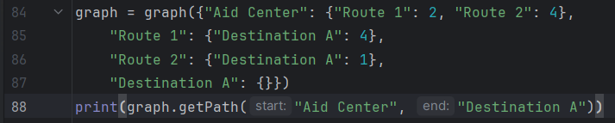

Visual representation of the graph:
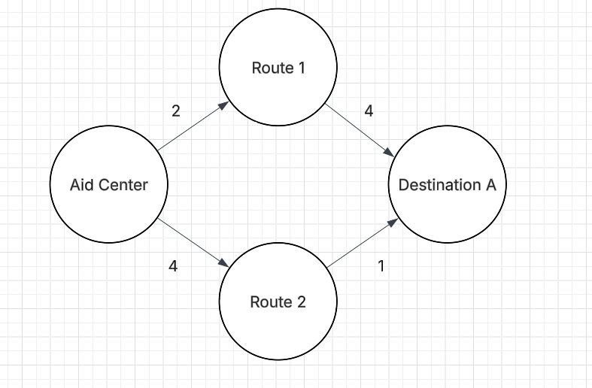

Best path output:

Execution Results and Analysis
Visualization of input graph: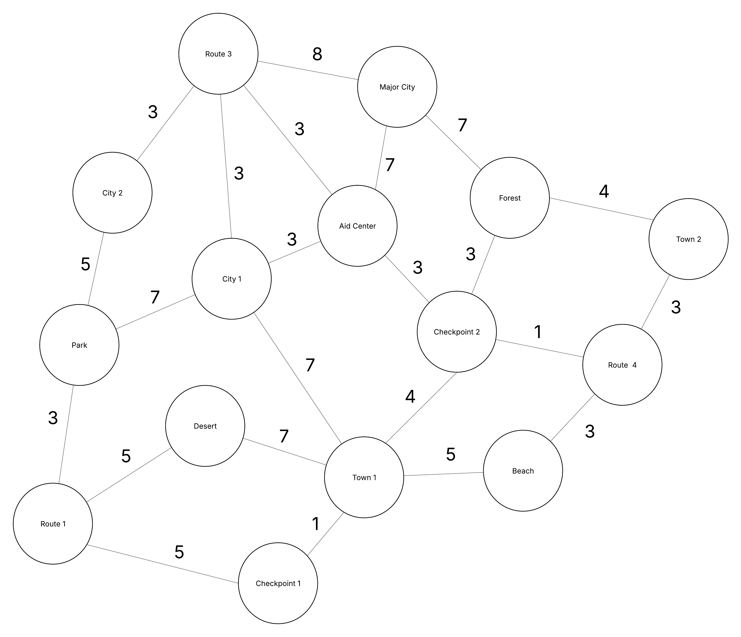
Best Path Output (for Town 2 specifically):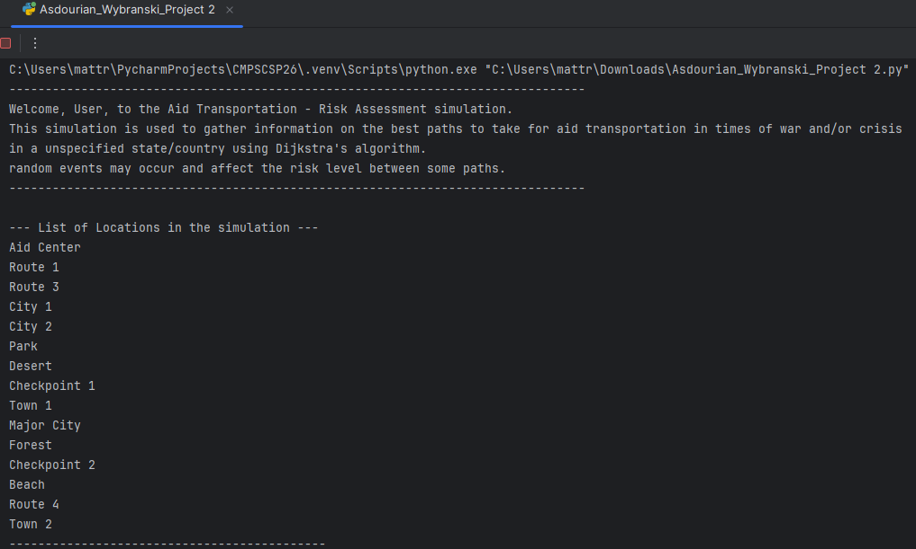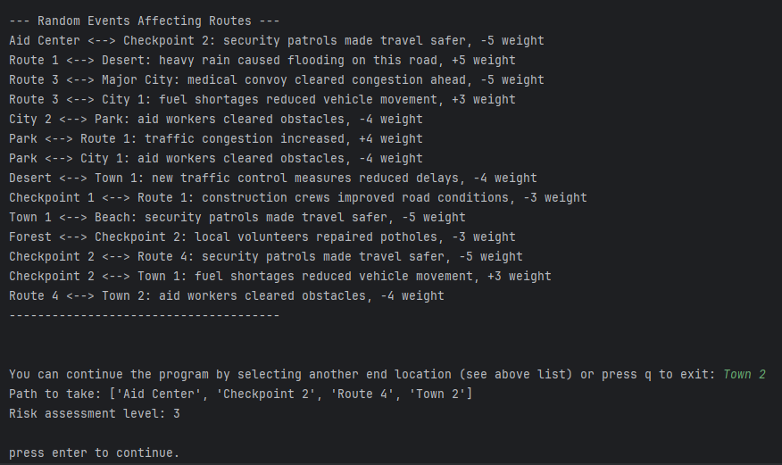
At the top of the console you will find a welcome message that is displayed at the start of the program for the user. Below that, the user is presented with a list of locations and a list of random events. The random events change for each delivery and create a layer of complexity and randomness to our graph traversal.

Next, The user is asked to input a delivery location and is presented with the path taken and risk level. In this example, Town 2 was selected as the delivery location. The path found was to go to checkpoint 2, then to route 4, and finally to town 2. Due to the random event generator, the path from the aid center to checkpoint 2, and the path from checkpoint 2 to route 4 received -5 weight from security patrols making the roads safer. Because of this the risk assessment level of the chosen path fell to 3 which made Dijkstra’s choose It as the best path.

Our results clearly show a working simulation of how Dijkstra’s algorithm can benefit simulations of aid transportation in places going through crisis/war. The example used above shows the fastest, lowest risk path from the “Aid Center” to “Town 2”.

Conclusions
Our overall findings revolved around simulating aid distribution and path locating using Dijkstra's algorithm to achieve a low risk level. Risk level is equivalent to the weight that edges have between nodes and is used to better define and analyze the path chosen by Dijkstra’s. Our random events show how unpredictable life can be and that it's not as easy going from point A to point B in a real-world scenario. Our biggest challenge was making sure that our main graph and events lined up well enough to be an accurate representation of possible real-world scenarios in a way that can be helpful for training those in organizations that provide aid such as Doctors Without Borders. The largest application of course learning that we utilized was Dijkstra’s algorithm. We decided early on that Dijkstra's algorithm was the most optimal solution to the issue of aid delivery as it allows the user to simulate the fastest path with the smallest possible risk even when random events change the risk level between locations.

AI Usage
AI Tools were not used in the making of this project.

